**DATABASE MANAGEMENT SYSTEM LAB**

**BCA-DS-155A**

**Manav Rachna International Institute**

**of Research and Studies**

**School of Computer Applications**

**(Department of Computer Applications)**

|  |  |
| --- | --- |
| **Submitted By** | |
| **Student Name** | **Sneha Pathak** |
| **Roll No** | **24/SCA/BCA(AI&ML)/064** |
| **Course** | **Bachelor of Computer Applications (BCA)** |
| **Semester** | **1st Semester** |
| **Section/Group** | **D/D2** |
| **Department** | **Computer Applications** |
| **Batch** | **2024-27** |
|  | |
| **Submitted To** | |
| **Faculty Name** | **Mr. Sijo Joseph** |

|  |  |
| --- | --- |
|  | **SCHOOL OF COMPUTER APPLICATIONS** |

## Experiment No: 1

Student Name: Sneha Pathak

UID: 12301401N105

Date of Performance: 25/8/2023

**Creating 3 Tables Name Student,Employee and courses.**

-- Creating the Student table

CREATE TABLE Student (student_id INT PRIMARY KEY, student_name VARCHAR(40) NOT NULL, address VARCHAR(300), gender VARCHAR(15), course VARCHAR(8));

-- Inserting values into the Student table

INSERT INTO Student (student_id, student_name, address, gender, course) VALUES

(1, 'John Doe', '123 Elm Street', 'Male', 'MCA'),

(2, 'Jane Smith', '456 Oak Avenue', 'Female', 'BCA'),

(3, 'Mike Brown', '789 Pine Road', 'Male', 'MBA'),

(4, 'Lisa Ray', '321 Maple Lane', 'Female', 'BBA'),

(5, 'Tom White', '654 Cedar Blvd', 'Male', 'PhD');

-- Creating the Course table

CREATE TABLE Course ( course_id NUMBER(3) PRIMARY KEY, course_name VARCHAR2(20) NOT NULL, location VARCHAR2(20));

-- Inserting values into the Course table

INSERT INTO Course (course_id, course_name, location) VALUES

(101, 'MCA', 'Building A'),

(102, 'BCA', 'Building B'),

(103, 'MBA', 'Building C'),

(104, 'BBA', 'Building D'),

(105, 'PhD', 'Building E');

-- Creating the Employee table

CREATE TABLE Employee ( emp_id int(4) , emp_name varchar(40) NOT NULL, department_id int(3), salary int, commission int);

-- Inserting values into the Employee table

INSERT INTO Employee (emp_id, emp_name, department_id, salary, commission) VALUES

(7369, 'Smith', 10, 5000.00, NULL),

(7777, 'Allen', 20, 6000.00, 200.00),

(2233, 'Jones', 30, 7000.00, 300.00),

(8900, 'Scott', 10, 5500.00, NULL),

(5678, 'James', 40, 7500.00, 500.00);

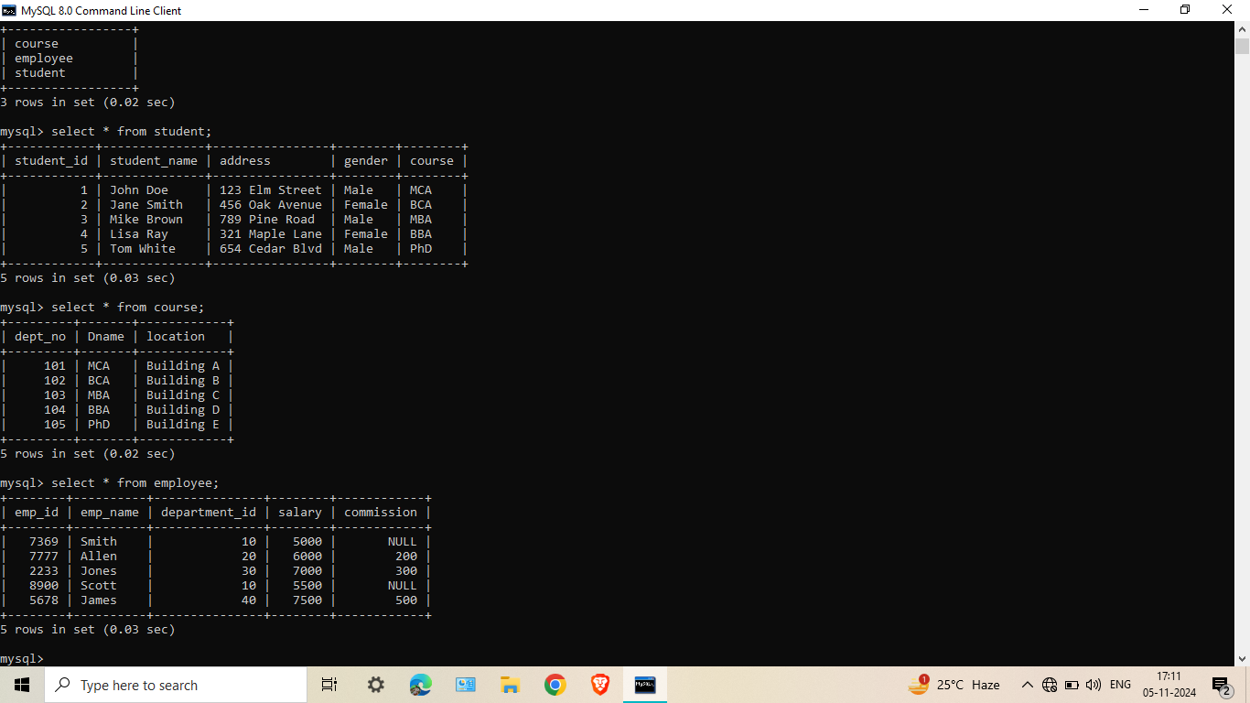

## Experiment No: 2

**Experiment :-** List all information about all students from the student table

SELECT * FROM Student;

Student Name: Sneha Pathak

UID: 12301401N105

Date of Performance: 29/8/2023

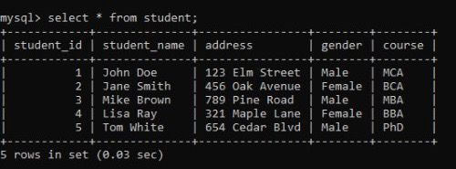

## Experiment No: 3

**Experiment 3:-** List all student numbers along with their courses

SELECT student_id, course FROM Student;

Student Name: Sneha Pathak

UID: 12301401N105

Date of Performance: 03/9/2023

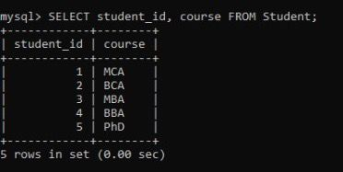

**Experiment No: 4**

**Experiment 4:-** List course names and locations from the Course table

SELECT Dname, location FROM Course;

Student Name: Sneha Pathak

UID: 12301401N105

Date of Performance: 12/9/2023

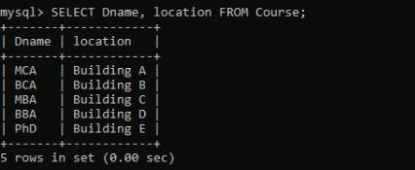

## Experiment No: 5

**Experiment 5:-** List the details of the students in MCA course

SELECT * FROM Student WHERE course = 'MCA';

Student Name: Sneha Pathak

UID: 12301401N105

Date of Performance: 15/9/2023

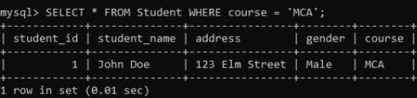

## Experiment No: 6

**Experiment 6:-** List the names of the employees whose employee numbers are 7369, 7777, 2233

SELECT emp_name FROM Employee WHERE emp_id IN (7369, 7777, 2233);

Student Name: Sneha Pathak

UID: 12301401N105

Date of Performance: 20/9/2023

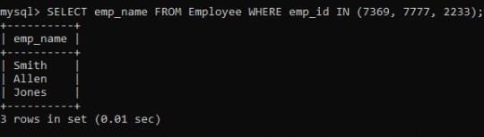

## 

## Experiment No: 7

**Experiment 7:-** List the employee names not belonging to department 10, 40

SELECT emp_name FROM Employee WHERE department_id NOT IN (10, 40);

Student Name: Sneha Pathak

UID: 12301401N105

Date of Performance: 29/9/2023

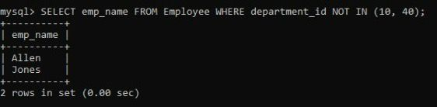

## 

## Experiment No: 8

**Experiment 8:-** List the employee names who are not eligible for commission

SELECT emp_name FROM Employee WHERE commission IS NULL;

Student Name: Sneha Pathak

UID: 12301401N105

Date of Performance: 02/10/2023

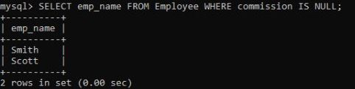

## Experiment No: 9

**Experiment 9:-** List the employees whose names start with “S” (uppercase only)

SELECT emp_name FROM Employee WHERE emp_name LIKE 'S%';

Student Name: Sneha Pathak

UID: 12301401N105

Date of Performance: 09/10/2023

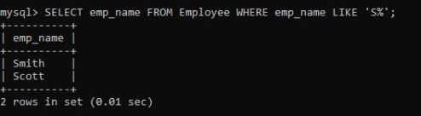

## Experiment No: 10

**Experiment No. 10:-** List the employees ending with name “s”

SELECT emp_name FROM Employee WHERE emp_name LIKE '%s';

Student Name: Sneha Pathak

UID: 12301401N105

Date of Performance: 15/10/2023

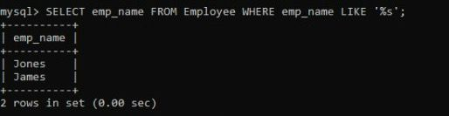

## Experiment No: 11

**Experiment 11:-** Display all the Arithmetic functions used in SQL

SELECT salary, salary + 500 AS Add_500, salary - 200 AS Subtract_200, salary * 1.1 AS Increase_10_percent, salary / 2 AS Half_Salary FROM Employee;

Student Name Sneha Pathak

UID: 12301401N105

Date of Performance: 21/10/2023

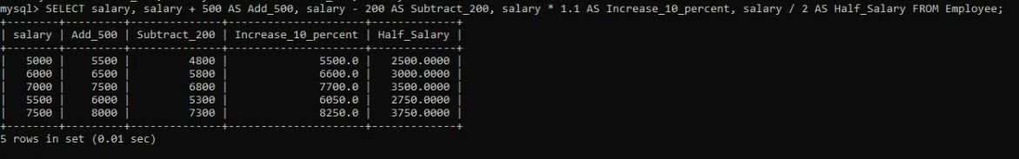

## Experiment No: 12

**Experiment 12:-** List the names, salary and PF amount of all employees (PF is calculated as 10% of salary)

SELECT emp_name, salary, (salary * 0.10) AS PF_amount FROM Employee;

Student Name: Sneha Pathak

UID: 12301401N105

Date of Performance: 25/10/2023

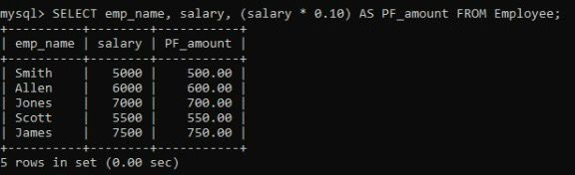

## Experiment No: 13

**Experiment 13:-** List the employee names having “k” as the second character

SELECT emp_name FROM Employee WHERE emp_name LIKE '_k%';

Student Name: Sneha Pathak

UID: 12301401N105

Date of Performance: 30/10/2023

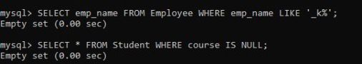

## Experiment No: 14

**Experiment 14:-** List the students not assigned to any department

SELECT * FROM Student WHERE course IS NULL;

Student Name: Sneha Pathak

UID: 12301401N105

Date of Performance: 03/11/2023



## Experiment No: 15

**Experiment 15:-** . List the student details in ascending order of course

SELECT * FROM Student ORDER BY course ASC;

Student Name Sneha Pathak

UID: 12301401N105

Date of Performance: 16/11/2023

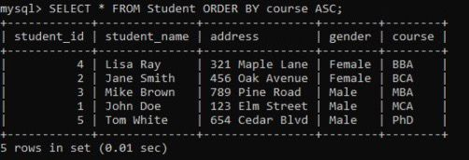

## Experiment No: 16

**Experiment 16:-** List the number of students in BCA course

SELECT COUNT(*) AS BCA_Student_Count FROM Student WHERE course = 'BCA';

Student Name: Sneha Pathak

UID:12301401N105

Date of Performance: 20/11/2023

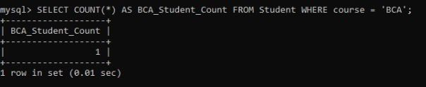

## Experiment No: 17

## Experiment 17:- List the number of students available in student table

## SELECT COUNT(*) AS Total_Students FROM Student;

Student Name: Sneha Pathak

UID:12301401N105

Date of Performance: 20/11/2023

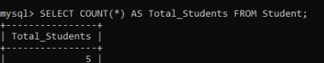

## Experiment No: 18

## Experiment 18:- CREATE TABLE Department ( dept_id INT PRIMARY KEY, dept_name VARCHAR(30) NOT NULL);

Student Name: Sneha Pathak

UID:12301401N105

Date of Performance: 20/11/2023

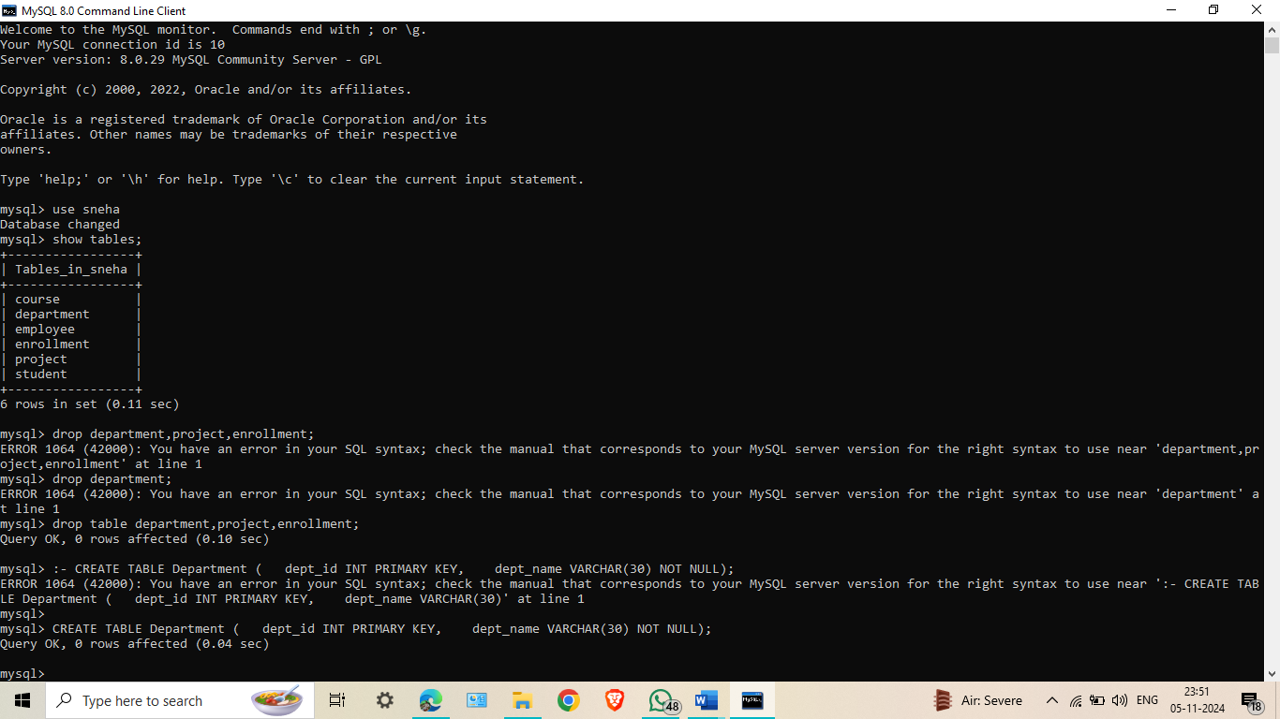

## Experiment No: 19

## Experiment 19:- Create a table with all columns having NOT NULL constraints

CREATE TABLE Project ( project_id INT PRIMARY KEY, project_name VARCHAR(50) NOT NULL, start_date DATE NOT NULL, end_date DATE NOT NULL);

Student Name: Sneha Pathak

UID:12301401N105

Date of Performance: 20/11/2023

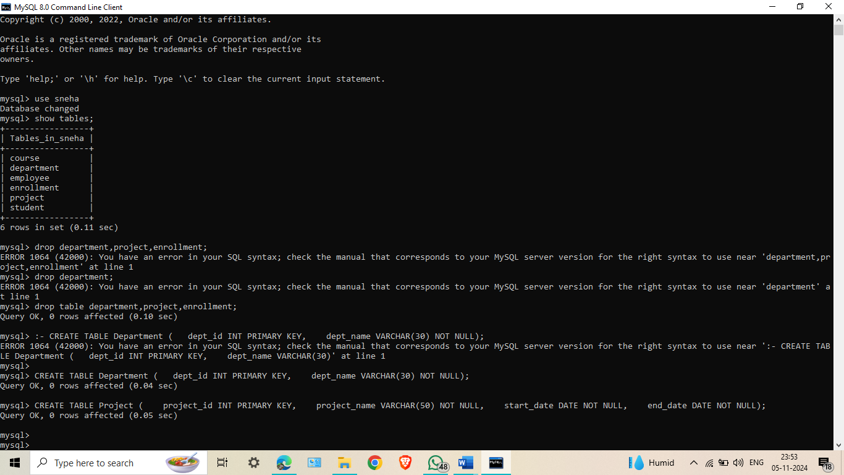

## Experiment No: 20

## Experiment 20:- Create a table with a unique key constraint

## CREATE TABLE Faculty ( faculty_id INT PRIMARY KEY, faculty_name VARCHAR(40) NOT NULL, email VARCHAR(50) UNIQUE);

Student Name: Sneha Pathak

UID:12301401N105

Date of Performance: 20/11/2023

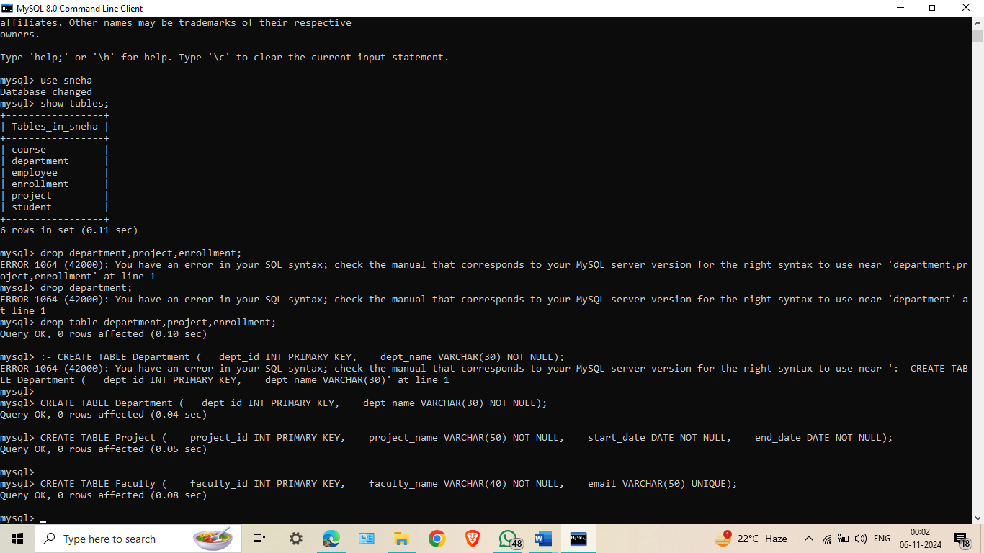

## Experiment No: 21

## Experiment 21:- Create a table with a unique key constraint

CREATE TABLE Faculty ( faculty_id INT PRIMARY KEY, faculty_name VARCHAR(40) NOT NULL, email VARCHAR(50) UNIQUE);

Student Name: Sneha Pathak

UID:12301401N105

Date of Performance: 20/11/2023

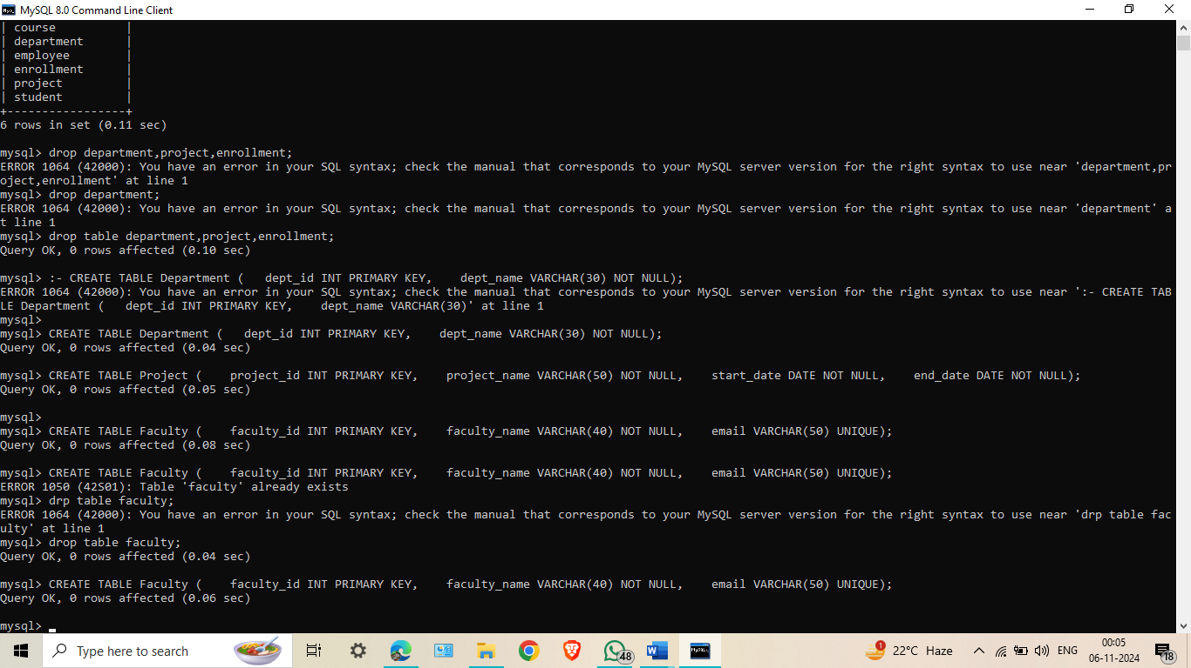

## Experiment No: 22

## Experiment 22:- Display the different students in department 1 and 2

## SELECT DISTINCT student_name FROM Student WHERE course IN (SELECT Dname FROM Course WHERE dept_no IN (1, 2));

Student Name: Sneha Pathak

UID:12301401N105

Date of Performance: 20/11/2023

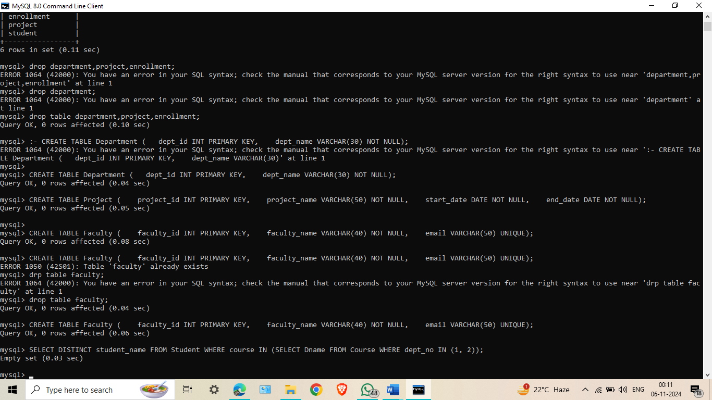

## Experiment No: 23

## Experiment 23:- Display the list of students ordered by course

## SELECT * FROM Student ORDER BY course;

Student Name: Sneha Pathak

UID:12301401N105

Date of Performance: 20/11/2023

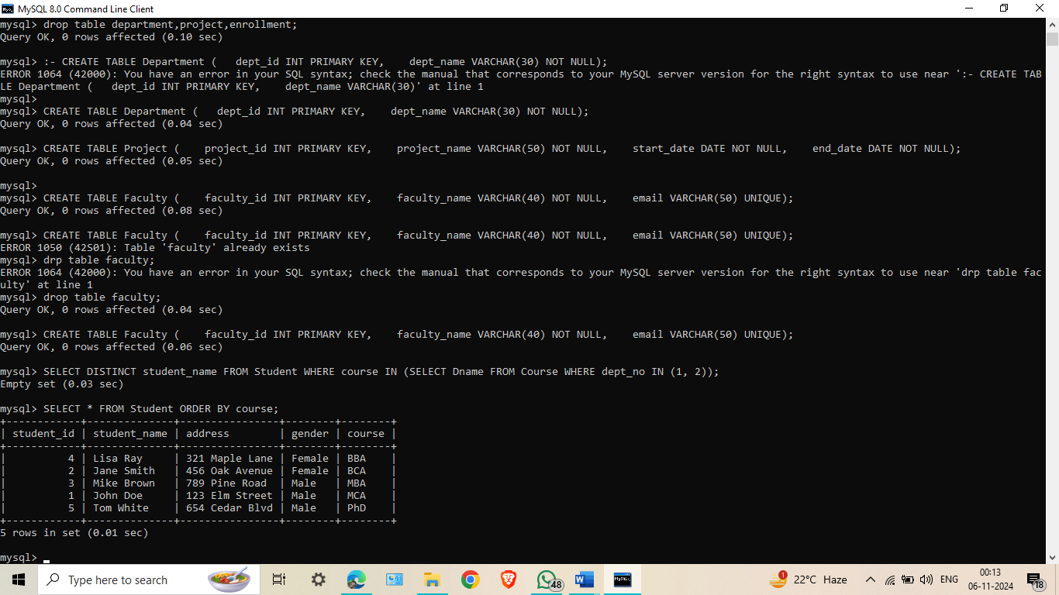

## Experiment No: 24

## Experiment 24:- Display the alphabetically sorted list of students

## SELECT * FROM Student ORDER BY student_name ASC;

Student Name: Sneha Pathak

UID:12301401N105

Date of Performance: 20/11/2023

